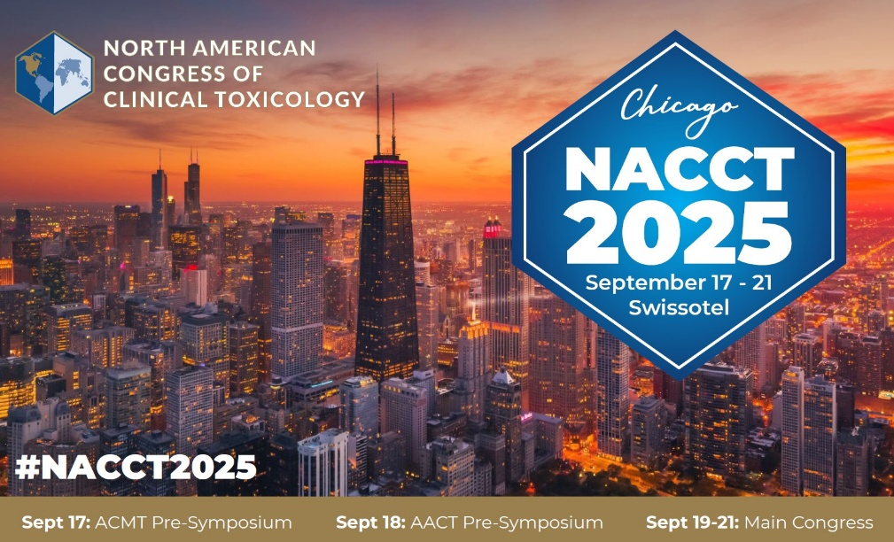

**Platform Session**

**Presenter Checklist**

**What is a** **Platform Presentation?**

These sessions are scheduled for either 60-minutes or 120-minutes—please see below. The date and time of your presentation has already been sent to you. If you are scheduled to present in a 120-minute platform session, each speaker presentation is 12 minutes, followed by a 2-3 minute Q&A session. If you are scheduled to present in a 60-minute platform session, each speaker presentation is 12 minutes, followed by a 2-3 minute Q&A session.

**Platform sessions times are:**

* **Friday 9/19 from 1:00pm – 3:00pm** 
  + Session Duration Time:  120 mins
* **Saturday 9/20 from 3:30pm - 4:30pm**
  + Session Duration Time:  60-mins
* **Sunday 9/21 from 1:00pm - 2:00pm**
  + Session Duration Time:  60-mins

**Platform Presenters must register to attend NACCT 2025 to participate in the symposium!** [**Click here to register today**](https://www.clintox.org/nacct)**. *Important note: Abstracts are subject to withdraw if presenting author does not register.***

**How to Format Your Presentation: (recommended)**

* Include no more than 12-15 slides (1 minute per slide)
* Summarize your slides in 10-12 minutes
* Allow for 2-3 minutes of questions from the audience
* All scientific presentations are 16x9, High Definition. Acceptable formats are PowerPoint or PDF.

**Audio-Visual Set-up for Oral Abstracts**

Platform sessions take place in the scheduled meeting rooms. The meeting rooms are equipped with a screen, laptop, projector, wired mic and small podium.

**General Guidelines**: **(Tips)**

* Hold microphone close to mouth when speaking so attendees can hear your presentation.
* One slide = One idea
* Do not use more than one slide per minute
* Limit the text on your slides – *focus on the main message*
* Use less than 20 words per slide
* Utilize clear visuals and graphics instead of text
* Limit abbreviations and unnecessary text
* Use bullet points instead of full sentences
* Make sure slides are clear and readable – double space your text
* Use clear fonts and contrasting colors
* Avoid the use of ALL CAPITAL letters or underlined text, as they are difficult to read
* Remember, your slide must be readable from the back of the session room
* Prevent using font sizes smaller than 18pt
* Cite your sources

**Questions?**

Please e-mail NACCT Staff with any questions at [NACCT@clintox.org](mailto:NACCT@clintox.org).

We look forward to seeing you in Chicago!

Sincerely,

NACCT