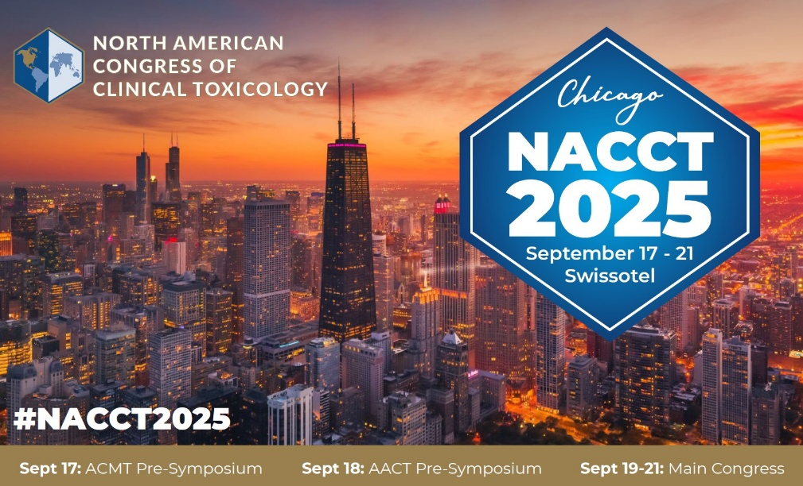

**FIT Platform**

**Presenter Checklist**

**What is a FIT Platform?**

A **FIT Platform** an abstract selected by the Convener or Program Committee to be presented in a symposium at NACCT 2025. Each presentation is 12-minutes (*10 mins presentation time, 2 mins for Q&A*). **Additionally**, there is a poster presentation ON THE SAME DAY as the oral presentation. The date and time of your presentation has already been sent to you.

**Poster presentation times are below:**

* **Friday 9/19 from 9:30am-10:30am** 
  + Set Up - Thursday 9/18 from 1:30pm - 5:00pm
  + Required Display Time Friday 9/21 from 8:30am - 12:00pm
  + Break Down - Friday 9/21 from 12:00pm - 1:00pm
* **Saturday 9/20 from 9:30am-10:30am**
  + Set Up - Friday 9/19 from 5:30pm - 6:30pm
  + Required Display time Saturday 9/20 from 8:30am - 12:00pm
  + Break Down - Saturday 9/20 from 12:00pm - 1:00pm
* **Sunday 9/21 from 12:30pm-1:30pm**
  + Set Up - Saturday 9/20 from 3:00pm - 3:30pm
  + Required Display time Sunday 9/21 from 8:00am - 12:00pm
  + Break Down - Sunday 9/21 from 12:00am - 1:00pm

**FIT Platform Presenters must register to attend NACCT 2025 to participate in the symposium!** [**Click here to register today**](https://www.clintox.org/nacct)**. *Important note: Abstracts are subject to withdraw if presenting author does not register.***

**How to Format Your (oral) Presentation: (recommended)**

* Include no more than 10-12 slides (1 per minute)
* Summarize your slides in 10 minutes
* Allow for 2 minutes of questions from the audience
* All scientific presentations are 16x9, High Definition. Acceptable formats are PowerPoint or PDF.

**Audio-Visual Set-up for Oral Abstracts**

Oral abstracts take place in symposia scheduled in meeting rooms. The meeting rooms are equipped with a screen, laptop, wired mic and small podium.

**General Guidelines (tips)**:

* Hold microphone close to mouth when speaking so attendees can hear your presentation.
* One slide = One idea
* Do not use more than one slide per minute
* Limit the text on your slides – *focus on the main message*
* Use less than 20 words per slide
* Utilize clear visuals and graphics instead of text
* Limit abbreviations and unnecessary text
* Use bullet points instead of full sentences
* Make sure slides are clear and readable – double space your text
* Use clear fonts and contrasting colors
* Avoid the use of ALL CAPITAL letters or underlined text, as they are difficult to read
* Remember, your slide must be readable from the back of the session room
* Prevent using font sizes smaller than 18pt
* Cite your sources

**Questions?**

Please e-mail NACCT Staff with any questions at [NACCT@clintox.org](mailto:NACCT@clintox.org).

We look forward to seeing you in Chicago!

Sincerely,

NACCT