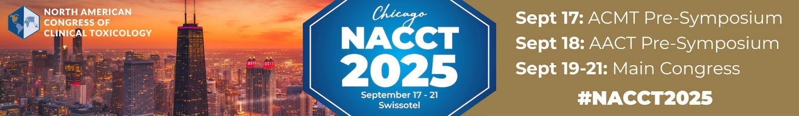
NACCT 2025 Abstract Submission Guidelines
Review this CHECKLIST as a guideline before you begin your submission.
- Only unpublished data not previously presented at other national or international meetings may be submitted. Abstracts presented at local or regional meetings may be submitted.
- Abstracts cannot be submitted to the NACCT that have already been published (print or electronic) before the NACCT abstract submission deadline at 11:59 PM EDT on Wednesday, April 30, 2025.
- Abstracts must include the following sub-categories:
  - Research Studies: Title; background; methods; results; conclusions.
  - Case Series/Case Report: Title; background; case report/case series; discussion; conclusions.
  - Do not include references in your submission.
- The abstract should be written in complete sentences using grammatically correct English. Spell out all abbreviations on the first usage.
- Abstracts are limited to 500 words.
- Tables and graphs are not included in the 500-word count.
- (3) small tables and/or graphs may be uploaded using the tool provided by the website. Images may be uploaded for the abstract review process only. They will not be published with the abstract.
- All abstracts must be blinded. Authors, including, for example, names of poison centers, should not be identified in any way on the page containing the abstract. Author names, contact information, and affiliations will not be included in the material sent to reviewers.
- Authors cannot edit data in the abstracts once the review process has been completed. Any inquiries regarding abstract corrections should be sent to nacct@clintox.org and will be reviewed by the Abstract Committee Chair and Vice Chair. Do NOT email the publisher or Clinical Toxicology co-editors with requests.
- The submitting author is responsible for ensuring the list of authors is complete and correct at the time of submission. No changes to authors will be allowed once the abstract has been submitted.
- Abstracts will be reviewed for oral and poster presentations.
- All presenters of accepted abstracts must register for the NACCT 2025 conference.

For more information on NACCT 2025, go to www.clintox.org.

Questions? Please contact: nacct@clintox.org

