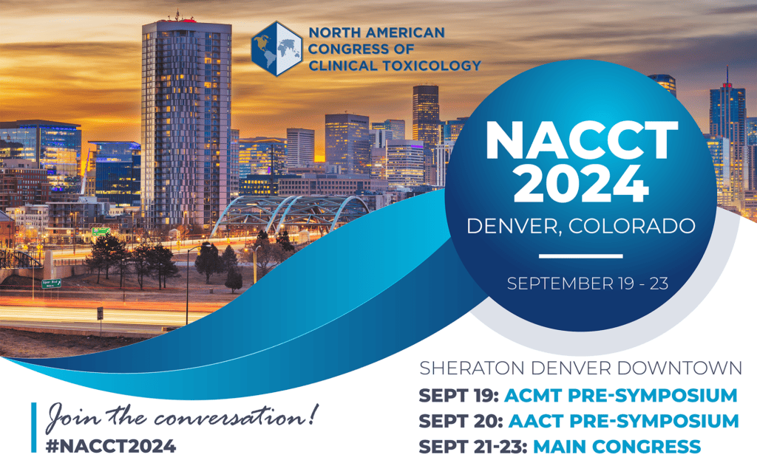

Poster Presentation

Checklist

**What is a Poster Presentation?**

Poster Presentations are held on **Saturday, Sunday, and Monday** in the **Exhibit and Poster Hall** at NACCT Meeting 2024. Each poster stays during the designated time, as assigned.

**[If you don’t remember your poster presentation time, please view the schedule here](https://degnonassociatesinc.sharepoint.com/:x:/s/degnonallmembers/ETZpOAMkX5hFh0wiWr0xu6EBOL4vCMaaO_TAUqzSZrSOHA?e=7NYSYB)**

**Poster presentation times are**

* **Saturday 9/21 from 9:30am-10:30am** 
  + Set Up- Friday 9/20 from 1:00pm - 5:00pm
  + Required Display Time Saturday 9/21 from 9:00am - 4:00pm
  + Break Down - Saturday 9/21 from 4:00pm - 4:45pm
* **Sunday 9/22 from 11:00am-12:00pm**
  + Set Up - Saturday 9/21 from 5:00pm - 5:45pm
  + Required Display time Sunday 9/22 from 9:00 AM - 1:30 PM
  + Break Down - Sunday 9/22 from 4:00pm - 4:30pm
* **Monday 9/23 from 12:30pm-1:30pm**
  + Set Up - Sunday 9/22 from 5:00pm - 6:00pm
  + Required Display time Monday 9/23 from 9:00am - 1:30pm
  + Break Down - Monday 9/23 from 1:30am - 3:00pm

Poster Presenters must be available at posters during the assigned presentation date and time. The date, time, and location of your poster presentation was included on your disposition letter.

**Poster Presenters must register to attend NACCT 2024 to participate in the meeting. *Important note: Abstracts are subject to withdraw if presenting author does register.***

**How to Format Your Poster:**

* Size: Posters should be no larger than 8’ (L) x 4’ (H)
* In the upper left-hand corner of your poster:
  + Clearly note your assigned presentation number and date
  + Final poster numbers will be published in the Itinerary Planner in late July
* Centered at the top of your poster:
  + Author name(s) and institution
* In the upper right-hand corner of your poster, place
  + Your Institution
  + Phone Number
  + Email Address
* On main area of the poster, include a reproduction of your abstract with the following headings (which should be in 40 pt font):
  + - Introduction
    - Methods
    - Results
    - Conclusions
    - References
    - Discussion (optional)
    - Important Notes: Commercial, product, and corporate logos must NOT be placed on posters or poster boards, however, institutional logos are permitted. Please be sure to communicate this policy if the poster is being designed and printed for you by someone else.

**General Guidelines**:

* Posters should stimulate discussion; do not give a long presentation
  + Keep text to a minimum – use bullets, they’re easier to read
  + Emphasize graphics
  + Limit abbreviations and unnecessary text; balance text and figures
  + Spellcheck your work!
* Utilize handouts to supplement your poster
* Materials must be easily read at a distance of 4 feet
  + Avoid handwriting text
  + Use 14pt or larger double-spaced text; recommended fonts are Arial, Calibri, Century Gothic, Geneva, ad Helvetica (San serif fonts)
  + Use clear fonts and contrasting colors
* When choosing a background, remember neutral or grey colors will be easier on the eyes than a bright color. Color photos look best when mounted on grey.
* View these slides for tips on developing an effective poster.
* When presenting:
  + Make eye contact
  + Give attendees a moment to read your science before discussing
  + Make it easy to remember
  + “Sell Your Science” in 10 seconds
  + Know your stuff
  + Network, network, network
  + If you wish to further a discussion away from the Poster, visit Track Hubs in the Exhibit and Poster Hall
  + Have business cards and contact information easily available

**Other Important Information:**

* Make sure to bring a copy of your acceptance letter to gain access to the Exhibit and Poster Hall for set-up. Poster presenters may access the Exhibit and Poster Hall beginning at 9:30am with a badge and credentials.
* Remember to bring an electronic copy of your poster (just in case), especially if you are checking your poster on a plane (not recommended) or shipping your poster.
* Posters must be mounted on your assigned and numbered poster board before 10:30 am on the day of your scheduled presentation.
* Posters must be removed during date/time indicated above.
* **ePosters**
* Poster Presenters may upload an ePoster. Instructions for uploading ePosters will be sent in May 2022.

**Questions?**

Please e-mail NACCT Meetings Staff with any questions at [nacct@clintox.org](mailto:nacct@clintox.org)

We look forward to seeing you in Denver!

Sincerely,   
NACCT