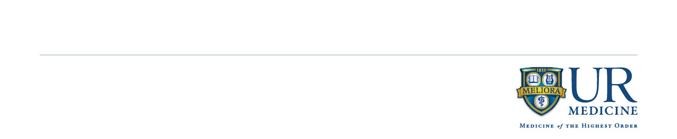

**Attention Medical Toxicologists Seeking Academic Employment Opportunities**

We are actively recruiting Medical Toxicology faculty at **University of Rochester Medical Center in Rochester NY**. We have a new *ACGME accredited Medical Toxicology Fellowship*, a busy inpatient and outpatient consultation services, and a robust educational curriculum for residents as well as medical students. Rochester NY is in the heart of the finger lakes and offers an ideal setting for a balanced and healthy work and family life.

**Position Description**

The ideal candidate for this position will staff the inpatient blended Medical Toxicology and Addiction Medicine consultation service. They will take an active role in Medical Toxicology Fellow education. In addition to fellow level education, the candidate will oversee resident and medical student Medical Toxicology rotation and education. In addition to staffing the Medical Toxicology consultation service, the candidate would staff one of our affiliate emergency departments, with opportunity for diverse practice environments ranging from urban academic medical center to rural emergency departments. We offer competitive compensation for time allocated to Medical Toxicology clinical and educational activities. Our department is ripe with opportunity for research engagement and support, as well as educational content development.

The candidate must have a Medical Doctorate or Doctor of Osteopathy, with board certification in Emergency Medicine. They must be board eligible or board certified in Medical Toxicology.

Interested parties should submit a CV to Dr. Nicholas Nacca

Nicholas_Nacca@urmc.rochester.edu

Department of Emergency Medicine | 601 Elmwood Avenue – Box 655 – Rochester, NY 14642