AACT Career Achievement Recipients

2011
Barry Rumack MD, FAACT
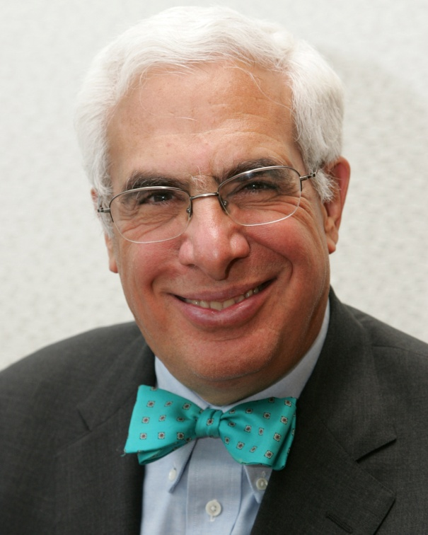
Barry Rumack, MD, has won the AACT’s Career Achievement Award for 2011. This unique and prestigious award is presented to an AACT member who has demonstrated extraordinary service to the profession of clinical toxicology throughout their career. A committee of past Career Achievement awardees selects the recipient each year from a list of candidates proposed by Fellows of the Academy to the AACT Nominating Committee.
Dr. Rumack was the director of the Rocky Mountain Poison and Drug Center from 1974 through 1991 and is now director emeritus. He was Professor of Pediatrics at the University of Colorado School of Medicine and is now emeritus retired. In addition to his academic pursuits he founded Poisindex, a toxicology database and developed other databases as part of Micromedex and then the Thomson Corporation. He served as president of the American Association of Poison Control Centers from 1982 to 1984 and was chairman of the American Board of Medical Toxicology from 1988 to 1990. He has published more than 200 original scientific articles, presented numerous abstracts at scientific meetings and written many chapters and books. His primary research interest has been in general toxicology with a special interest in acetaminophen and mushrooms. He was appointed by the Governor to the Colorado State Board of Health and has served on advisory committees to the Consumer Products Safety Commission, the Governor of Colorado for the Rocky Mountain Arsenal, Food and Drug Administration, Institute of Medicine and others. He is married to Carol M. Rumack, MD Professor of Radiology and Pediatrics and Dean of Graduate Medical Education at the University of Colorado.
The award presentation will be made at the AACT Members and Fellows Reception held at the Omni Shoreham Hotel on Saturday, September 24th. As part of the award, Dr. Rumack will present the AACT’s Career Achievement Lectureship in Las Vegas at NACCT in 2012.
2012 Frederick Lovejoy, Jr.

2012
Frederick Lovejoy, Jr. MD, FAACT
Frederick H. Lovejoy, Jr., MD is the William Berenberg Distinguished Professor of Pediatrics at the Harvard Medical School, Associate Physician-in-Chief, and Deputy Chairman of the Department of Medicine at the Boston Children’s Hospital. He currently serves as Executive Secretary of the Harvard Medical School Pediatrics Executive Committee.
He is a graduate of St. Paul’s School, Yale University (B.A.), the University of Virginia School of Medicine (M.D., AOA), and Harvard University (MA(Hon)). He served as an intern and resident (1970-1972) and Assistant to the Physician-in-Chief (1972-1974) at the Children’s Hospital, Boston. He has served as Chief of the Division of Clinical Pharmacology and Clinical Toxicology (1982-1987), and Chief of Pediatric Inpatient Services (1994-1997). He was the Director of the Boston Poison Information System (1972-1978) and Founder and Director of the Massachusetts Poison Control System (1978-1987). He was a founder of the Boston Combined Residency Program (1995-2007).
He is a member of the American Academy of Pediatrics, the American Pediatric Society, The American Board of Pediatrics, The American Clinical and Climatological Association, and The American Academy of Clinical Toxicology. He was a member of the Board of Directors and is a past President of The American Academy of Clinical Toxicology and a past Chairman of the Board of Medical Toxicology.
He has served on the editorial boards of Developmental Pharmacology and Therapeutics, Clinical Toxicology, Medical Toxicology/Drug Safety, Pediatric Emergency Care, and Pediatrics-in-Review.
He is a recipient of the Sidney Farber House-staff Award and the Charles A. Janeway Teaching Award from the Children’s Hospital; the Valentina Donahue-Turner Award, the Student Teaching Award in 1979 and 1986, designation as a Distinguished Scholar of the Academy at Harvard Medical School; the Raven Society and the Outstanding Medical Alumnus Award from the University of Virginia School of Medicene, the Outstanding Alumnus Award from the Fenn School; an outstanding Alumnus for Service from St. Paul’s School; the Ross Educational Award and Fellow Achievement Award from the Section on Poisoning & Injury Prevention, both from the AAP; the 1995 Recognition Award from the AAPCC; the Mathew J. Ellenhorn Award for Excellence in Medical Toxicology from the ACMT, and the Robert Holm Leadership Award from the Association of Pediatric Program Directors.
He is an author of over 120 original publications, editor, and author of over 70 book chapters and over 100 abstracts. He is an editor of The New Child Health Encyclopedia, Dell Publishing Co., The Celebration, Harvard Printing and Publishing Co, Images of America, Children’s Hospital Boston, Arcadia Publishing and Charles A. Janeway, Pediatrician to the World’s Children, Harvard University Press.

2013
John Doull MD,PhD, FAACT
Dr. Doull is Professor Emeritus of Toxicology at the University of Kansas Medical School. He received his BS in Chemistry from Montana State College in 1944 and his PhD (Pharmacology) and MD from the University of Chicago in 1950 and 1953. Prior to coming to the University of Kansas in 1967, he was an Associate Professor of Pharmacology and the Assistant Director of the Toxicity Laboratory at the University of Chicago. He is certified in toxicology by the Academy of Toxicological Sciences and the American Academy of Clinical Toxicology. He is a past president of the Society of Toxicology and the American Board of Toxicology and served on the Toxicology Study Section of NIH and the council of NIEHS. He was a member of the Presidential/Congressional Risk Assessment and Management Commission, the Mrak commission and the White House Woolridge Report Committee. He has served as a trustee for the International Life Sciences Institute, the American Academy of Clinical Toxicology and the Toxicology Forum. He chaired the Toxicology and many other committees of the National Academy of Sciences, the Threshold Limit Value committee of ACGIH and has served on advisory Panels for EPA, FDA, DHHS, FEMA, FIFRA, WRAIR, NCTR, DISCUS, and NIOSH. He consults with local and international government, industrial and private organizations, is the founding co-editor of Casarett and Doull’s Toxicology; The Basic Science of Poisons and is a member of Sigma Xi and AOA.
Dr. Doull received the Kenneth DuBois Award from the Midwest SOT in 1985 and the Kuna award from Rutgers in 1989. In 1990 he received the Commander’s Award for Public Service from the Armed Forces Epidemiological Board and the International Achievement Award from the International Society of Regulatory Toxicology. In 1991 he received a Distinguished Medical Alumnus Award from the University of Chicago and the Ambassador of Toxicology Award from the Mid-Atlantic SOT. He received the Stokinger Award from ACGIH and the first John Doull Award from the Mid America section of SOT in 1992. He received the Merit Award from SOT in 1993 and the Snider Award from the University of Arkansas in 1994. In 1996 he received the Distinguished Service Award from the American College of Toxicology, the CIIT Founders Award, the ACGIH Meritorious Service Award and an honorary Doctor of Pharmacy from the University of Kuopio (Finland). He received the Shubik Award from the Toxicology Forum and became a NAS National Associate in 2002. He received the first Founders Award from SOT in 2008 and the Mildred S. Christian Career Achievement Award from the Academy of Toxicological Sciences in 2013.

2014
William Banner MD, PhD, FAACT
Dr. William Banner has been a long-standing participant in the American Academy of Clinical Toxicology and has been a Fellow of the Academy since 1987. Bill grew up in the suburbs of New York City and moved to Tennessee for high school. He attended the University of Memphis and then medical school at the University of Tennessee and stayed there for residency training in pediatrics. It was there that he got his first taste of clinical toxicology doing rotations with Dr. Peter Chyka and publishing articles on caffeine toxicity and paraldehyde toxicity. He left Memphis to do a fellowship in clinical pharmacology at the University of Arizona and also enroll in graduate school earning a PhD in pharmacology. During his time in Tucson he became involved with the nascent poison control center at the University of Arizona and worked with Al Picchioni, Ted Tong, and Jude McNally to provide clinical services and even occasionally sleeping on the poison center floor through the night. He was forced by geography to become interested in venomous creatures and after spending more clinical time in pediatrics he became interested in the critical care aspects of toxicology and received additional training to become board-certified in both medical toxicology and critical care. He attended his first toxicology meeting in Chicago and presented on the subject of paraldehyde, a drug which has fortunately faded into memory.
After leaving Arizona he joined the faculty at the University of Utah and served as Chair of the American Board of Medical Toxicology as it transitioned to become the American College of Medical Toxicology. In the 1980’s he was involved in several committee responsibilities of the AACT until being elected to the Board of Trustees in 1986. He served continuously as a member of the board until ultimately serving as president from 1994 to 1996. He considers his major contribution to the AACT to be the recommendation that the AACT assume a major responsibility for the North American Congress and in particular to use the Contemporary Forums meeting planning group to assist in transitioning to a large professionally run, multifaceted meeting as it is today.
Over time Dr. Banner has participated in the leadership of the three major organizations in clinical toxicology, the AACT, the ACMT, and the AAPCC. He has continued to publish and participate in presentations at the North American Congress but would hope to be remembered for his stage presence at the Salt Lake City meeting playing lead guitar and serving as First Officer to Capt. James T Chyka for the presentation “The History Of Poisoning In The Future: lessons from Star Trek”.
Dr. Banner currently serves on the board of the AAPCC and is now President-elect of that organization. He continues to work in the pediatric intensive care unit in Oklahoma City and to serve as medical director for the Oklahoma Center for Poison and Drug Information. He has continued to publish and plans to continue to present more original research in the future but would also like to reprise his role as lead guitarist and first officer.

2015
Lewis R. Goldfrank MD, FAACT
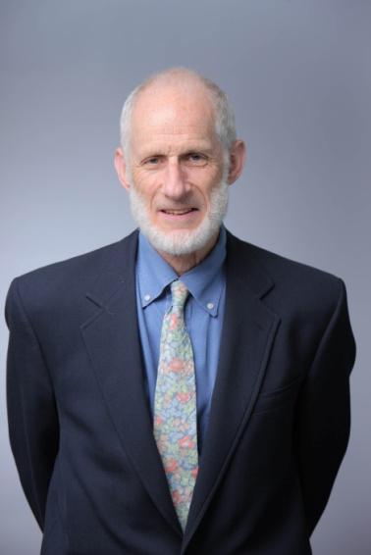

Lewis R. Goldfrank, MD, has worked at Bellevue Hospital Center and New York University (NYU) Medical Center for more than thirty years. He is currently the first Chairman and professor of the academic Department of Emergency Medicine at NYU, where he developed the emergency medicine and medical toxicology residencies of the medical school. Dr. Goldfrank is the medical director of the New York City Health Department’s Poison Center. His career has been spent working in the public hospitals of New York City, emphasizing the role of emergency medicine in improving access to care, public health, public policy, and medical humanism. He has assisted in numerous projects in Africa, South America, Asia, and Europe advancing emergency medicine, medical toxicology and global health.

His investigations in preparedness include developing and leading a consortium on preparedness with the NYC Department of Health, leading the New York University School of Medicine Consortium on Preparedness, being the principal investigator for several grants from the Department of Homeland Security on Large Scale Emergency Readiness and the Department of Defense on Risk Management in the Healthcare setting.

He is a member of the National Academy of Sciences Institute of Medicine (IOM) and chaired the IOM Committees Responding to the Psychological Consequences of Terrorism, Evaluation of the Metropolitan Medical Response Systems Program, and Preparing for an Influenza Pandemic as well as the IOM Forum on Medical and Public Health Preparedness for Catastrophic Events.
Educated at Clark University, Johns Hopkins School of Medicine, and the University of Brussels, Belgium, he graduated from the University of Brussels Medical School in 1970. He completed his residency in Internal Medicine at Montefiore Hospital and Medical Center in 1973. He is the senior editor of “Goldfrank’s Toxicologic Emergencies” a standard text in the field now in its tenth edition.

2009 Ed Krenzelok PharmD, FAACT, DABAT, FEAPCCT
2008 Allister Vale MD, FAACT
2007 None
2006 Milton Tenenbein MD, FAACT (awarded at 2007 meeting)
2005 Mark Thoman MD, FAACT, FACMT, FAAP
2004 Bill Robertson MD, FAACT
2003 Tony Temple MD, FAAP, FAACT
2002 Ruth Lawrence MD, FAACT and Howard Mofensen
2001 Walt Decker PhD, FAACT
2001 Fred Oehme

