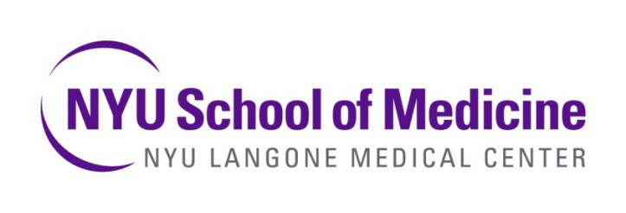
RONALD O. PERELMAN DEPARTMENT OF EMERGENCY MEDICINE
DIVISION OF MEDICAL TOXICOLOGY

The Division of Medical Toxicology of the Ronald O. Perelman Department of Emergency Medicine is recruiting a medical toxicologist to join one of the oldest and most prestigious medical toxicology groups in the country. The ideal candidate will be innovative and motivated to enrich the academic productivity of both the division and department. We have a particular interest in candidates who are interested in developing and leading a toxicology consult service. Other interests that are in line with the division interests include:

- Clinical Care
- Undergraduate and graduate medical education
- Research
- Public health
- Disaster and preparedness

Our department cares for over 300,000 patients annually at our clinical sites across Manhattan and Brooklyn. Our patient population is diverse and represents a community that is both ethnically and culturally rich. We are dedicated to providing the highest level of care to our patients and training the academic leaders of the future. The division is well integrated into the NYU School of Medicine curriculum. It also provides physician services to the New York City Poison Control Center, which covers a catchment area of over 12 million people. We are home to a well-established 2-year fellowship in Toxicology and provide core faculty support for the 4-year residency in Emergency Medicine.

Academic rank, effort and salary will be commensurate with education, training and experience. We offer an outstanding and comprehensive compensation and benefits package including retirement as well as moonlighting options and CME education opportunities. Eligible candidates must be board certified in Emergency Medicine and board-prepared or certified in Medical Toxicology.

NYU Langone Medical Center is an equal opportunity and affirmative action employer committed to diversity and inclusion in all aspects of recruiting and employment. All qualified individuals are encouraged to apply and will receive consideration without regard to race, color, gender, gender identity or expression, sex, sexual orientation, transgender status, gender dysphoria, national origin, age, religion, disability, military and veteran status, marital or parental status, citizenship status, genetic information or any other factor which cannot lawfully be used as a basis for an employment decision.

Please send your CV and cover letter to:

Robert S. Hoffman, MD
Director, Division of Medical Toxicology
Ronald O. Perelman Department of Emergency Medicine
robert.hoffman@nyumc.org

